Assigement (Moveinsync)
Name: Bhavesh Khokhar
College: Indian Institute of Information Technology Sonepat
Tech Stack Use:
Backend : Java Spring Boot
Frontend: React.js
Database: Mysql

Case Study : Intelligent Alert Escalation & Resolution System
Tables: Alert , Alert_transition, Alert_rule, Driver, Vechicle, Admin
Admin table:
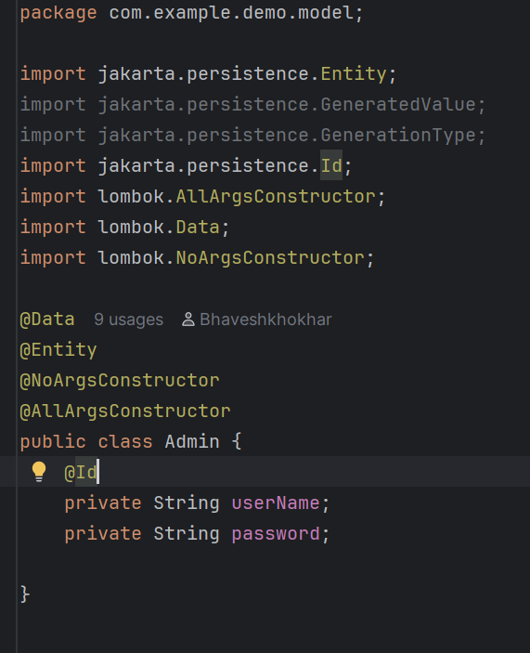
Driver table:
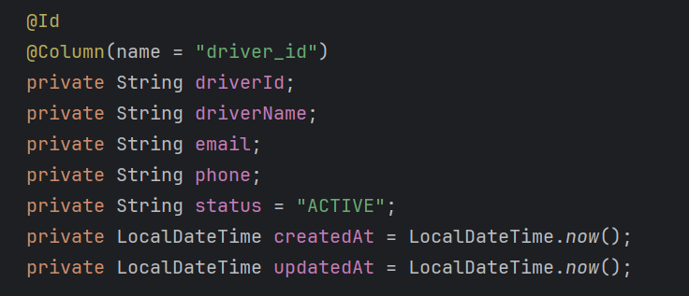
Vechicle Table:
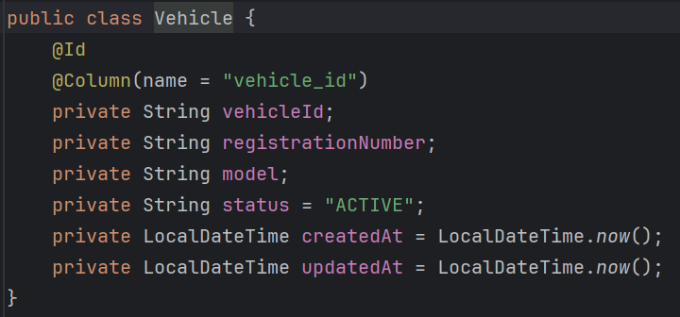
Alert_transition Table:
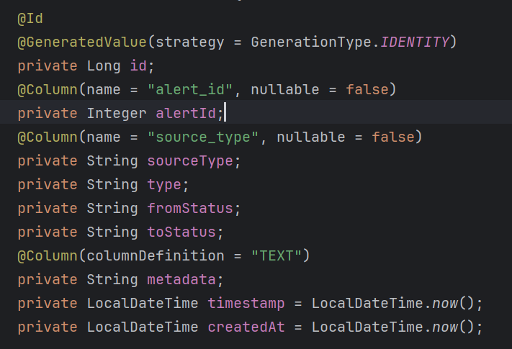
Alert table:
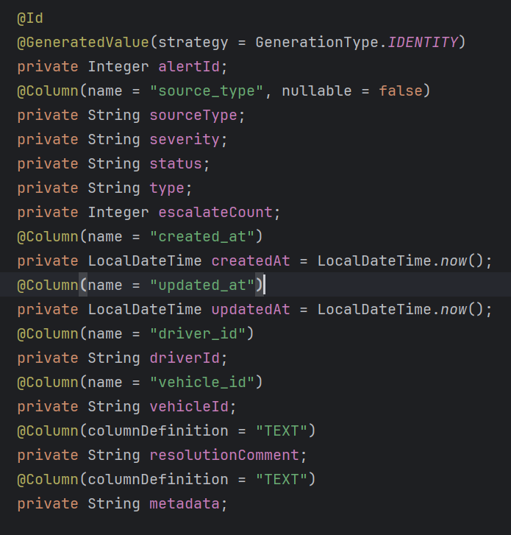
Admin_rule:
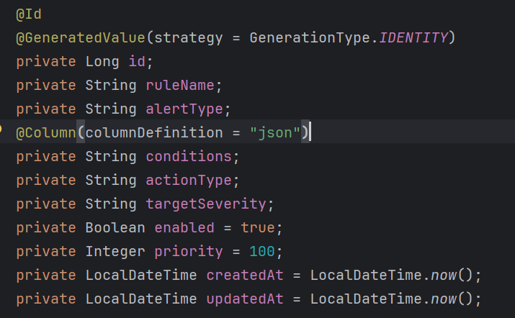
Endpoints
- /api/alerts (post)
- /api/alerts (Get)
- /api/alerts/trends (Get)
- /api/alerts/weekly (Get)
- /api/alerts/{alertId} (Get)
- /api/alerts/{alertId}/resolve (Put)
- /api/alerts/{alertId}/history (Get)
- /api/alerts/auto-close (Get)
- /api/dashboard/stats (Get)
- /api/dashboard/top (Get)
- /login (Post)
- /api/rules (Get)
- /api/rules/reload (Get)

Authentication
I have use JWT and Spring security for Authentication
- JSON Web Token (JWT) is used to securely transmit user authentication data between the client and server.
- After successful login, the server generates a signed JWT and sends it to the client.
- The client includes this token in the header of subsequent requests for authorization.
- The server verifies the token’s signature to ensure the request’s authenticity and user identity
- code snippets
- public class SecurityConfig {
- @Autowired
- private UserDetailsService userDetailsService;
- @Autowired
- private JwtFilter jwtFilter;
- @Bean
- public AuthenticationProvider authenticationProvider(){
- DaoAuthenticationProvider provider=new DaoAuthenticationProvider();
- provider.setUserDetailsService(userDetailsService);
- provider.setPasswordEncoder(new BCryptPasswordEncoder(12));
- return provider;
- }
- @Bean
- public SecurityFilterChain securityFilterChain(HttpSecurity http) throws Exception {
- http.cors(Customizer.withDefaults())
- .csrf(cutomizer->cutomizer.disable())
- .authorizeHttpRequests((request->request
- .requestMatchers("login","/actuator/prometheus")
- .permitAll().anyRequest().authenticated()))
- .httpBasic((Customizer.withDefaults()))
- .sessionManagement(seesion->seesion.sessionCreationPolicy(SessionCreationPolicy.STATELESS))
- .addFilterBefore(jwtFilter,UsernamePasswordAuthenticationFilter.class);
- return http.build();
- }
- @Bean
- public CorsFilter corsFilter() {
- return new CorsFilter(corsConfigurationSource());
- }

- private UrlBasedCorsConfigurationSource corsConfigurationSource() {
- CorsConfiguration config = new CorsConfiguration();
- config.setAllowedOrigins(List.of("http://localhost:5173"));
- config.setAllowedMethods(List.of("GET", "POST", "PUT", "DELETE", "OPTIONS", "PATCH"));
- config.setAllowedHeaders(List.of("Authorization", "Content-Type"));
- config.setAllowCredentials(true);

- UrlBasedCorsConfigurationSource source = new UrlBasedCorsConfigurationSource();
- source.registerCorsConfiguration("/**", config);
- return source;
- }
- @Bean
- public AuthenticationManager authenticationManager(AuthenticationConfiguration config) throws Exception {
- return config.getAuthenticationManager();
- }
- }

public class JwtFilter extends OncePerRequestFilter {
@Autowired
private JwtService jwtService;
@Autowired
ApplicationContext context;
@Override
protected void doFilterInternal(HttpServletRequest request, HttpServletResponse response, FilterChain filterChain) throws ServletException, IOException {
String authHeader=request.getHeader("Authorization");
String token=null;
String userName=null;

if(authHeader!=null&&authHeader.startsWith("Bearer ")){
token =authHeader.substring(7);
userName=jwtService.extractUserName(token);
}
if(userName!=null&& SecurityContextHolder.getContext().getAuthentication()==null){
UserDetails userDetails=context.getBean(MyUserDetailsService.class).loadUserByUsername(userName);
if(jwtService.validateToken(token,userDetails)){
UsernamePasswordAuthenticationToken authToken=new UsernamePasswordAuthenticationToken(userDetails,null,userDetails.getAuthorities());
authToken.setDetails(new WebAuthenticationDetailsSource().buildDetails(request));
SecurityContextHolder.getContext().setAuthentication(authToken);

}
}
filterChain.doFilter(request, response);
}
}
Frontend Side Form:
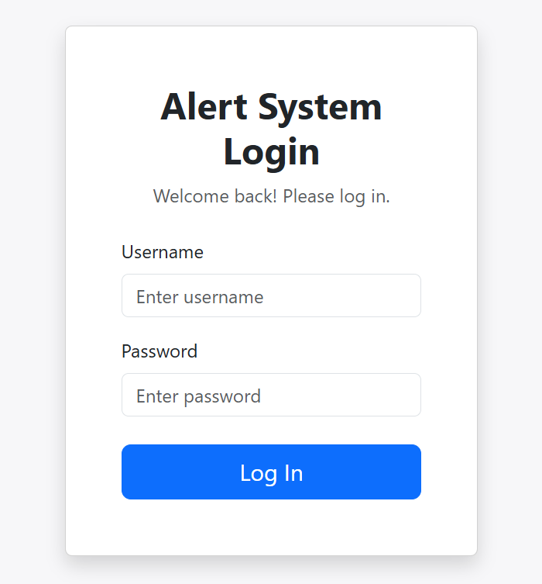

DashBoard
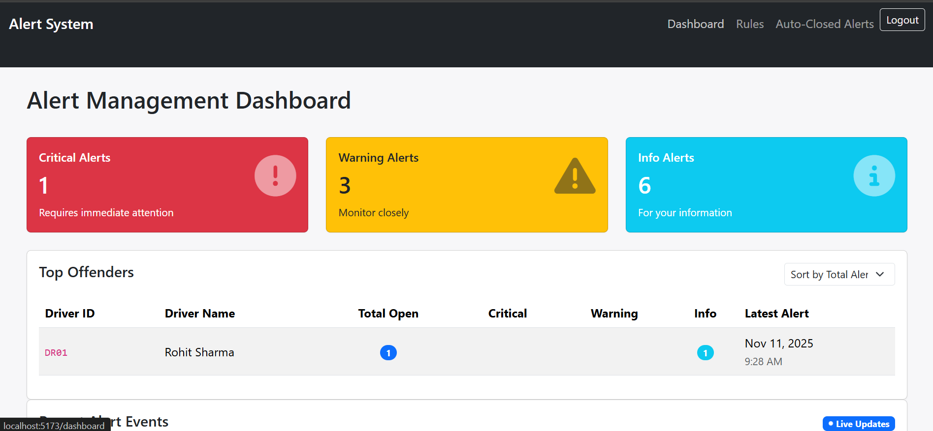
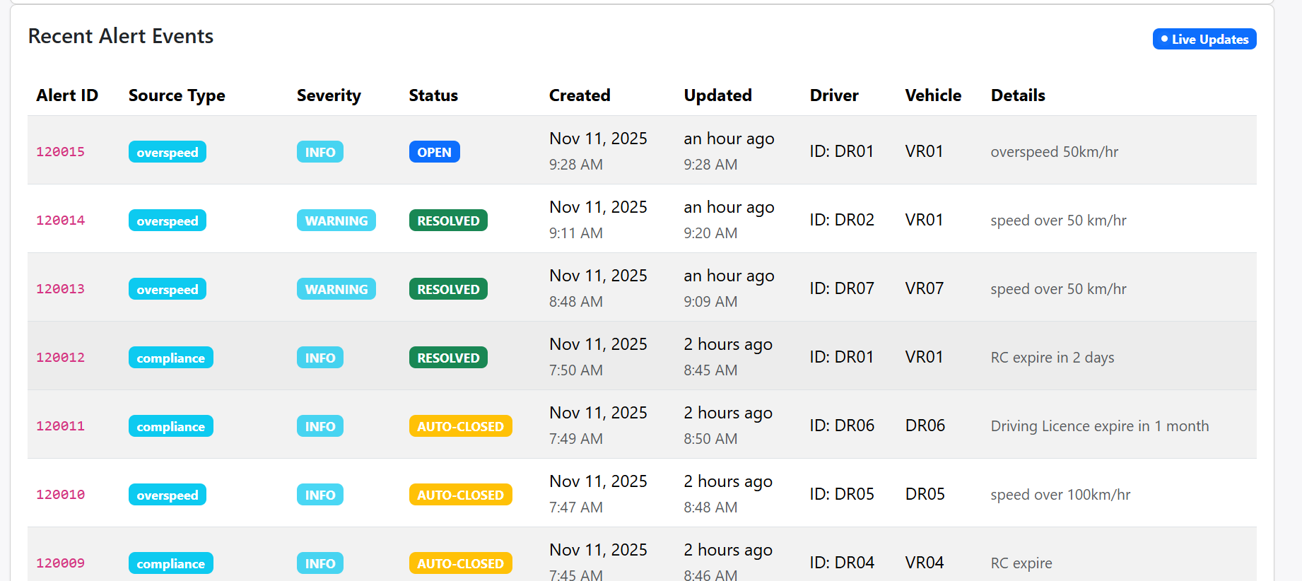
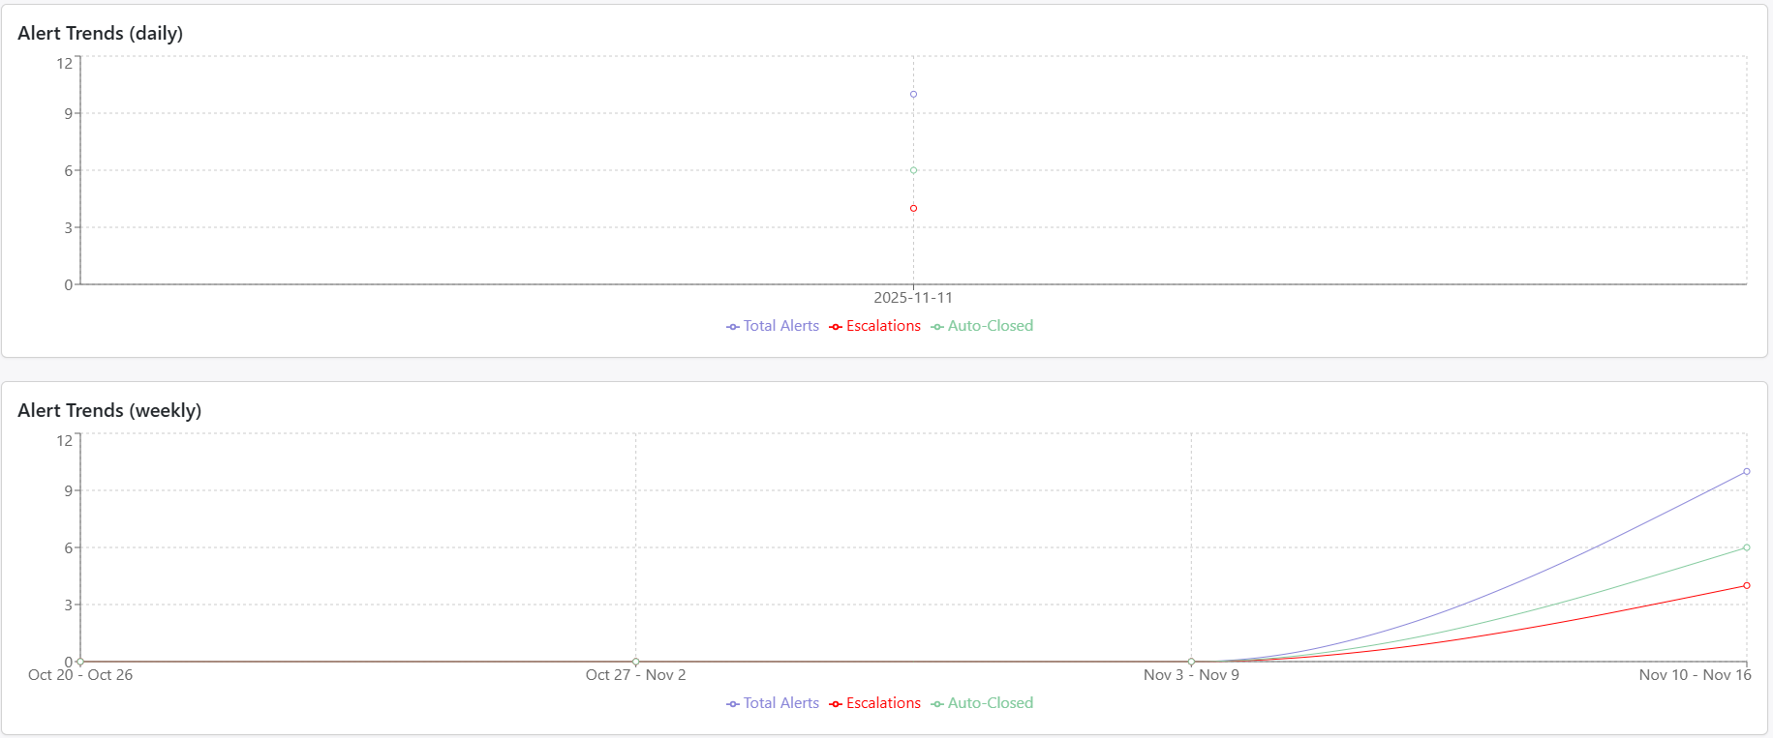
auto-close alert screen
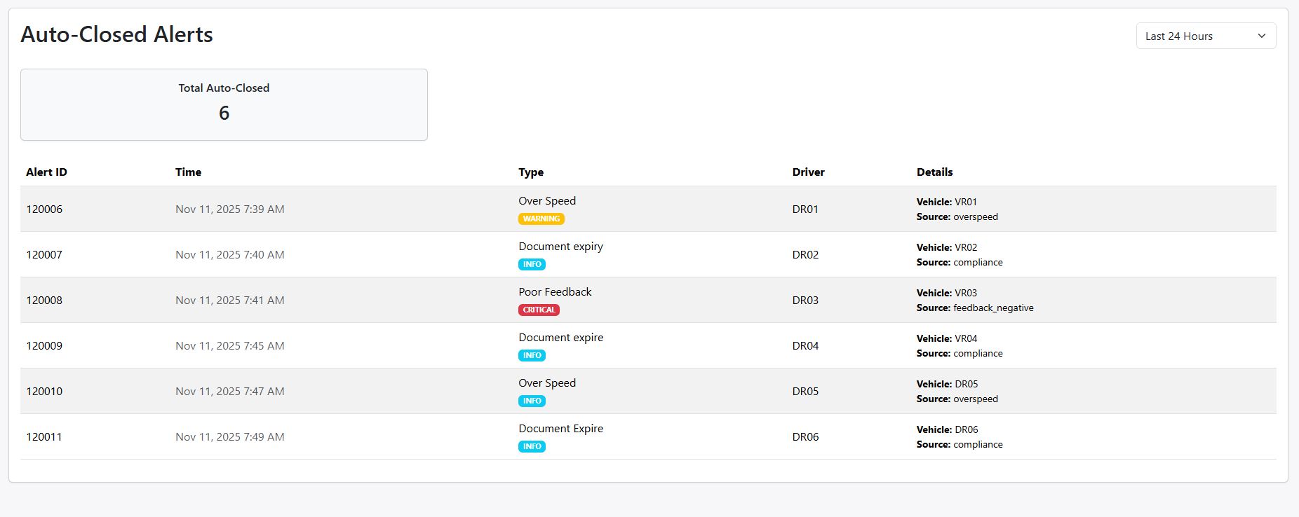
on click an alert show metadata
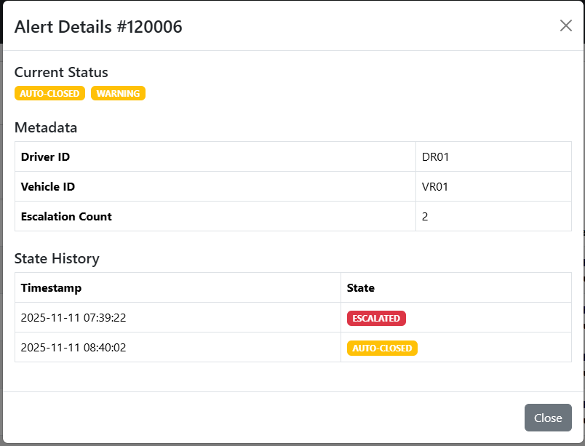

If alert is not resolve or auto-closed then it show resolve button for manual resolution
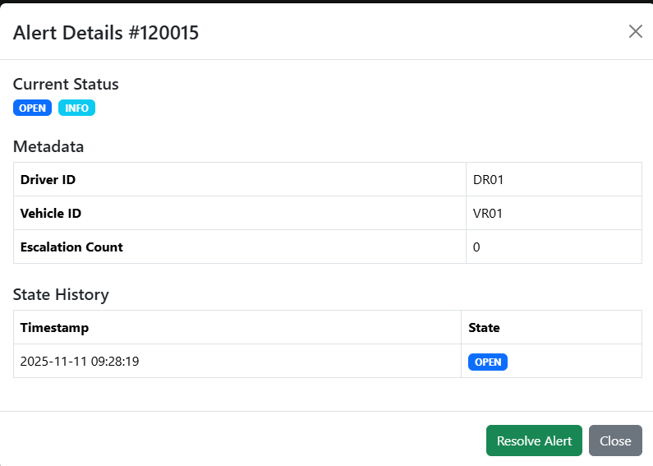
Admin rule
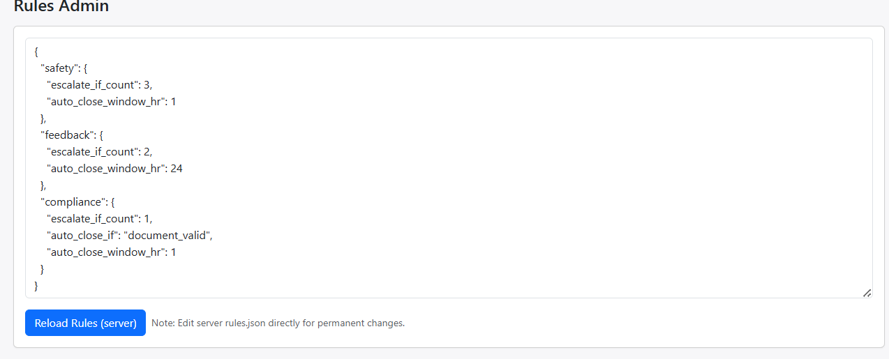

Trade-offs in the System
- Monolithic Spring Boot Application vs Microservices Architecture
Option | Pros | Cons | Decision
Monolithic (Current) | Easier to build and deploy; simpler development for a small team; all features in one codebase. | Harder to scale specific modules; a single failure can affect the whole app. | ✅ Chosen for simplicity and maintainability during early stages.
Microservices | Independent scaling and deployment; better fault isolation. | Higher complexity (service discovery, communication, versioning). | Deferred for future — will migrate when system traffic increases.

- Database Choice: MySQL vs NoSQL
Option | Pros | Cons | Decision
MySQL (Relational) | Strong consistency, ACID compliance, good for structured alert data. | Scaling write-heavy workloads can be difficult. | ✅ Chosen — ensures data integrity and supports complex queries (e.g., trends, aggregations).
NoSQL (MongoDB) | High scalability and flexible schema. | Weaker transactional support. | Deferred for future event-based analytics.

- Real-Time Data Updates: WebSocket vs Polling
Option | Pros | Cons | Decision
WebSocket (Push) | Real-time updates; efficient for live dashboards. | More complex backend setup; requires persistent connections. | ✅ Will implement once traffic justifies.
Polling (Every few seconds) | Simple to implement using React setInterval. | Slightly higher latency; more network requests. | Currently used for simplicity.

Error and Exception Handling:
for exception handling I have create global exception class also handle case special exception inside controller with try catch

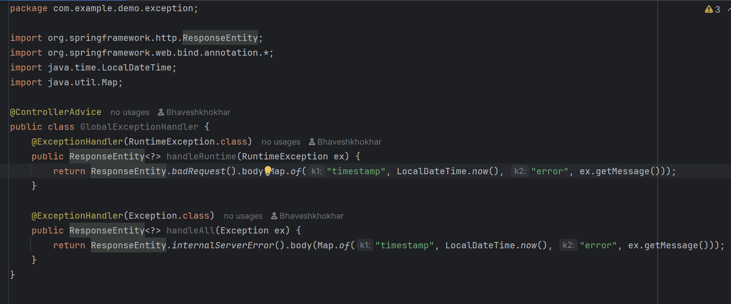

System Monitoring :
- For system monitoring I have create Grafana dashboard
- I have use Prometheus which scratch data every 15 sec and Grafana show the metric also I have use log in my server to identify and address issues(Slf4j)
- Grafana Dashboard
